Chapter 10 Test: 10.4-10.5
- f(x) = (x-3)² – 5
- The parabola opens upward
- The global minimum of the curve shifts to the right and downwards from the origin to (3, -5).
- Vertex (h, k) = (3, - 5)
- f(x) = -4(x-1)²- 1
- The parabola opens downward
- The global maximum of the curve shifts to the right and downwards from the origin to (1, -1).
- Vertex (h, k) = (1, -1).
- f(x) = -x² + 3
- The parabola opens downward
- The global maximum of the curve shifts upwards from the origin along the Y- axis to (0, 3)
- Vertex (h, k) = (0, 3).
The problem 7-9
- f(x) = 32 + 4x – x²
- Vertex (h, k) = (2, 36)
- The equation of the line of symmetry, x = 2
- The parabola opens downward
- Y- intercept = (8,0) and (-4, 0 )
- X – intercept = (0, 32)
The graph. f(x) = 32 + 4x – x²

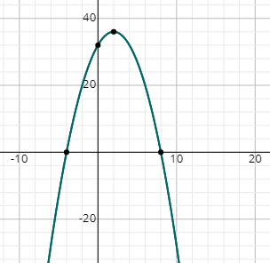

- f(x) = -2x² + 4x + 1
- Vertex (h, k) = (1, 3 )
- The equation of the line of symmetry, x = 1
- The parabola opens downwards
- X – intercept = ((2+√6)/2, 0), ((2-√6)/2, 0)
- Y – intercept = (0, 1)
The graph f(x) = -2x² + 4x + 1
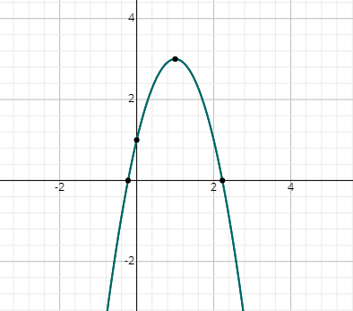
Ch. 10 Test: 10.1-10.2
- (p-3)² = 11; p = √11 + 3 , p = -√11 + 3
- (4x+3)² + 6=0 ; x = -3/4 + i(√6)/4, x = -3/4 – i(√6)/4
- P² + 4p + 10 = 0; p = -2 + √6i, p = -2-√6i
- X² + 4x = 9; x = (√13) – 2 , x = -2 - √ 13
- -8x = 4x² – 2; x = (√6 – 2)/2, x = - (2+√6)/2
- -5x + 9 + 2x² = 0; x = 5/4 + i(√47)/ 4, X = 5/4 – i(√47)/4
- 1/3x² + ¾ = x; x = 5/3, x = 15/11
- 2(3x² – 5x) + 3x = 2 – 7x; x = √(1/3), x = -√(1/3)
- 2x² + x = 6; x = 3/2, x = -2
- 3x² – 3x – 2; Two Irrational solutions
- 2x² -2x + 6; No real solution
- 9x² – 6x = -1; one real solution

